**Telco Customer Churn Analysis**

**Business Problem**

Telco is a Telephone company, a provider of telecommunications services, such as telephony and data communications. Telco is experiencing customer churn over some time and would want to know the like to know the reasons for the customer churn.

Telco would want us to analyze all relevant customer data and develop focused customer retention programs and predict the behavior to retain the customer



**Assumptions**

1. No unusual occurrences which will have a substantial impact on the data used

2. The information is still current and can be used to analyze a company’s possible plans in an efficient manner

3. The company is currently not using any of the suggested solutions

5. Customers are paying for the services used only after they have used the services and not at the time of signing up

**Research Questions**

1. What are the variables that affect the customer churn?

2. How can we predict the customer behavior?

3. What are the steps that the company can take to reduce the customer churn?

**Hypothesis**

1. Senior citizens are churning out significantly when compared to non-senior citizens

2. Customers with monthly contracts have an alarmingly high chance of churning out

3. Customers with electronic check payment method have a high churn rate

4. Churn rate of the customer decreases with increase in tenure

**Analysis**

As per analysis the data, we find that the total number of customers is 7043, out of which 5174 customers are still with the Telco and 1869 customers have churned out. So, Telco, is able to retain 73.46% of their customers whereas 26.54% of the customers have churned out

This is higher than usual, and we will need to check the reasons for the churn

|  |  |
| --- | --- |
|  |  |

Firstly, we are analyzing the data based on gender. When we check the churn details based on the gender, we are unable to find any relation between them. The gender-wise customer distribution is nearly equal, Telco has 2549 female customers against 2625 male customer. Out of this, 939 and 930 customers have churned out respectively. This means, the churn ratio is nearly equal for both the gender types, and we do not have trends gender-wise

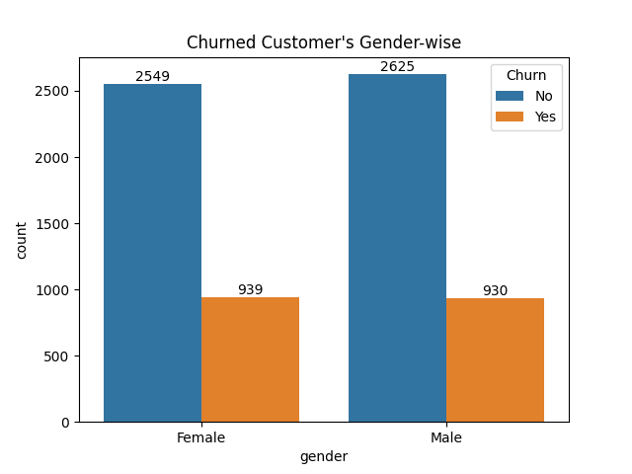

Next, we are checking the data related to senior citizen. Upon checking, we see that we mostly have customers who are not senior citizen, a total of 5901 customers are not senior citizen and 1142 customers are senior citizen

However, the actual finding was that the churn% among the senior citizens is much higher than the customers who are not senior citizens. We see that 23.6% of the customers have churned out who are not senior citizens, whereas, the churn% goes up to 41.7% when we consider the senior citizens

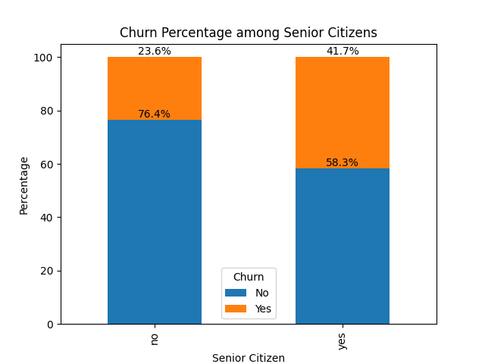

Coming to the churn% based on the monthly charges paid the customer, we are again unable to find any co-relation, we find the similar percent have churned irrespective of the monthly charges, so this does not seem to be a deciding factor

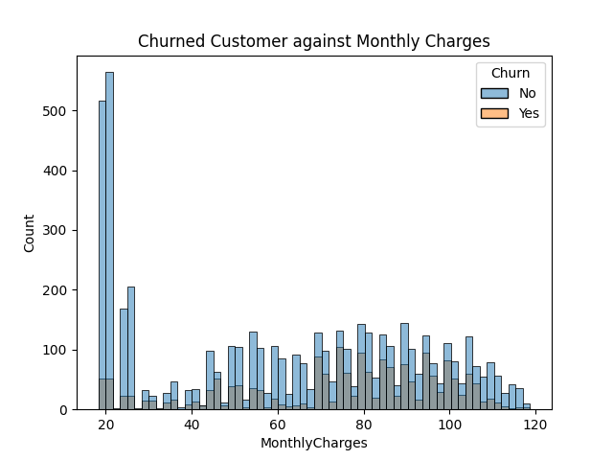

Another important finding is the churn% based on the contract type, here we are able to find that we have maximum number of customers having monthly contract, followed by two-year and one year contract has the least customers. Out of this, the churn% of the monthly contract customers are alarmingly higher and those of the other two types are more than acceptable. So, Telco really need to focus on this area

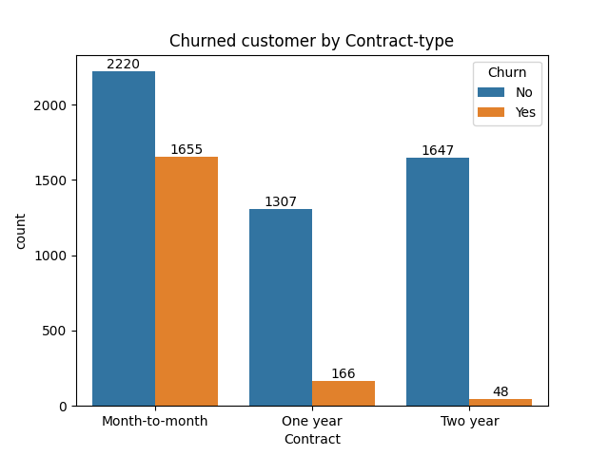

When we check the customer churn by Payment Method, we see that we have an equal share for all the payment method, however, the churned customers mainly belong to the Electronic check category. It is not easy to predict whether a co-relation exists between this, but this is something that can certainly be worth checking

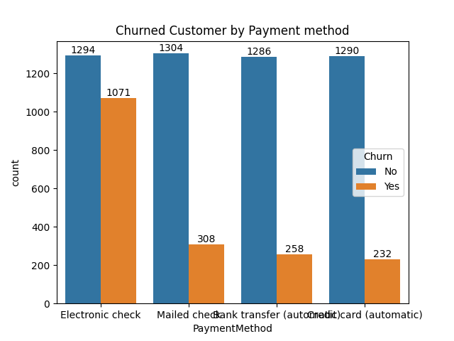

Next, when we investigate the customer churn based on the tenure, we see a clear trend where the customer churn decreases as the tenure increases and vice versa. The normal distribution curve of the histogram confirms the same

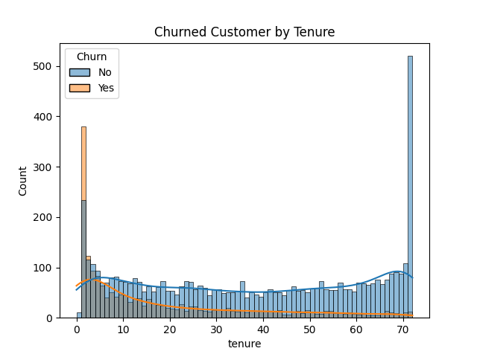

Finally, we take a look at the customer churn rate based on the services that we are offering. The conclusion here is that most of our customers are not using the services that we offer. On that, the customer not using tech support, online backup, online security have a high churn rate. The contrary would be the internet service, where there is a higher churn rate for customers using fiber optic

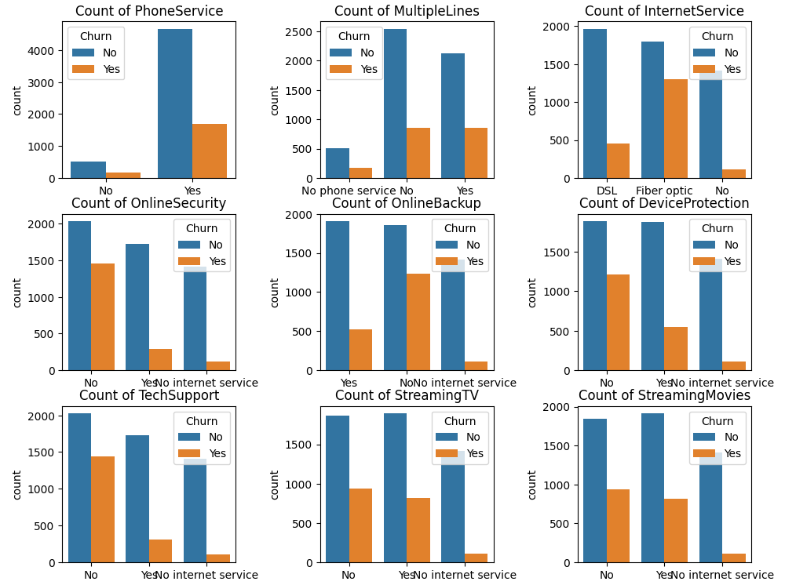

**Findings and suggestions**

1. The data suggests that Telco has very less senior citizen customers and those that are there also have a high churn rate, so the company needs to check the reasons for that. They need to promote more towards the senior citizen customers and maybe bring better offers for them, so that they have more senior citizens joining and staying with them

2. As per the data, customers who are choosing monthly contracts are having a very high rate of churn. So, the company needs to come up with strategies to convert the monthly contracts into yearly contracts or two-year contracts where the churn rate decreases rapidly

3. Continuing with the above point, we also see that the customers with less tenure with Telco has a high rate of churn, so the company needs to focus on making the yearly, two-yearly contracts more lucrative and attractive which will eventually help them in retaining their customers

4. Another interesting fact is that the customers with electronic check payment method have high churn rate. Though this does not directly indicate anything, but the company can talk to their customers to understand if there are any challenges with this payment method as the customers using other payment methods have a significantly lower churn rate

5. It is also observed that most of the Telco customers are not using the services offered by the company and churn ratio among those customers are also on the higher side. The company should take up initiatives to educate customers more about their services, so the customer can start using their preferred services which has a high chance of reducing the customer churn

**CONCLUSION**

Based on the Telco Churn Analysis, we find that the company is experiencing a higher churn rate than expected. We did analyze the factors that might be causing the customer churn rate to go higher and suggested the steps that the company should implement. We expect the customer churn rate of the company to reduce once they start implementing the steps